**CO543: Image Processing**

**Lab 2**

Ranage R.D.P.R. - E/19/310

The following is the original image that was used to implement the functions in the lab tasks.



The following functions are used throughout the lab to plot each figure to show the results.

import cv2

import numpy as np

import matplotlib.pyplot as plt

def show_2_images(image1, image2, title1, title2):

    fig, ax = plt.subplots(1, 2, figsize=(10, 5))

    ax[0].imshow(image1, cmap='gray')

    ax[0].set_title(title1)

    ax[1].imshow( image2, cmap='gray')

    ax[1].set_title(title2)

    plt.show()

def show_3_images(image1, image2, image3, title1, title2, title3):

    fig, ax = plt.subplots(1, 3, figsize=(15, 5))

    ax[0].imshow(image1, cmap='gray')

    ax[0].set_title(title1)

    ax[1].imshow( image2, cmap='gray')

    ax[1].set_title(title2)

    ax[2].imshow( image3, cmap='gray')

    ax[2].set_title(title3)

    plt.show()

**1. Image thresholding**

**Lab Task 01 : Write a function to perform image thresholding using point processing taking the image file and the threshold value from the user.**

# Function to to perform image thresholding using point processing

def image_thresholding(image_path, threshold_value):

    # Read the image in grayscale mode

    image = cv2.imread(image_path, 0)

    # Apply thresholding

    _, thresholded_image = cv2.threshold(image, threshold_value, 255, cv2.THRESH_BINARY)

    return thresholded_image

# Loading the original image

img = plt.imread('image.jpg')

thresh_img = image_thresholding("image.jpg", 100)

show_2_images(img,thresh_img,'Original Image', 'Thresholded Image')

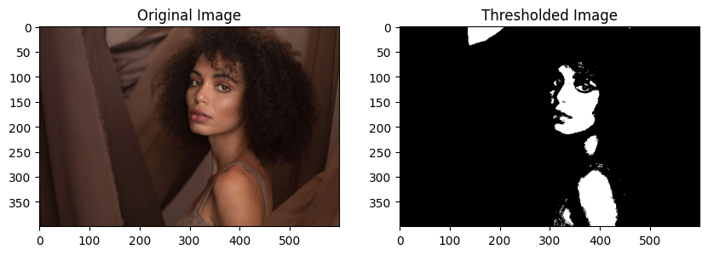

**2. Image arithmetic operations**

**Lab Task 02 : Read two images and perform addition and subtraction.**

**I=I1+I2; # Addition of two**

**I=I1-I2; # Subtraction of two images**

def image_addition(image1, image2):

    # Ensure both images have the same dimensions

    image2_resized = cv2.resize(image2, (image1.shape[1], image1.shape[0]))

    # Perform addition using OpenCV function

    add_image = cv2.add(image1, image2_resized)

    return add_image

img1 = plt.imread('image2.jpg')

img2 = plt.imread('image.jpg')

add_img = image_addition(img1,img2)

show_3_images(img1,img2,add_img,'Image 1', 'Image 2','Added Image')

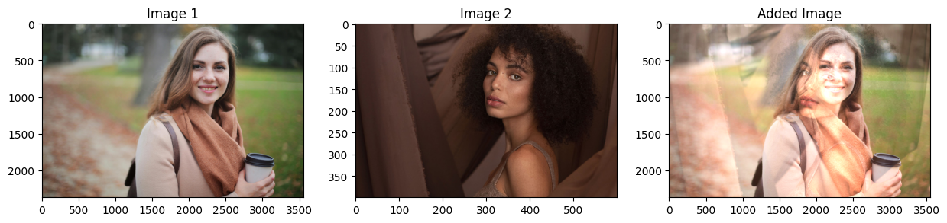

def image_subtraction(image1, image2):

    # Ensure both images have the same dimensions

    image2_resized = cv2.resize(image2, (image1.shape[1], image1.shape[0]))

    # Perform addition using OpenCV function

    sub_image = cv2.subtract(image1, image2_resized)

    return sub_image

sub_img = image_subtraction(img1,img2)

show_3_images(img1,img2,sub_img,'Image 1', 'Image 2','Subtracted Image')

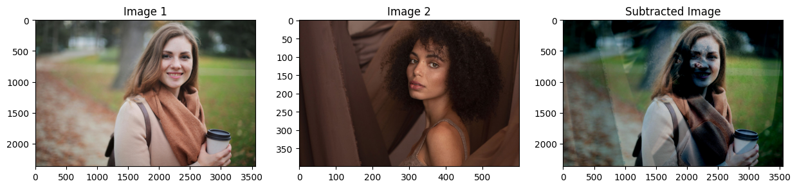

**3. Spatial Processing**

**i). Write simple programs to demonstrate the following. Show the original and resultant images in the same figure to compare them easily.**

# will use the gray scale image

gray_img = cv2.cvtColor(img, cv2.COLOR_BGR2GRAY)

plt.imshow(gray_img,cmap='gray')

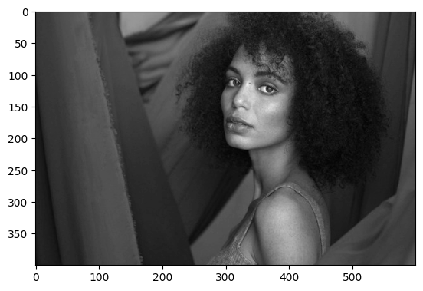

**a. Log transformation**

# Log transformation function

def log_transform(image):

    # Apply log transformation

    c = 255/(np.log(1 + np.max(img)))

    log_transformed = c * np.log(1 + img)

    # Specify the data type.

    log_transformed = np.array(log_transformed, dtype = np.uint8)

    return log_transformed

log_trans_img = log_transform(gray_img)

show_2_images(gray_img,log_trans_img,'Grayscale Image', 'Transformed Image')

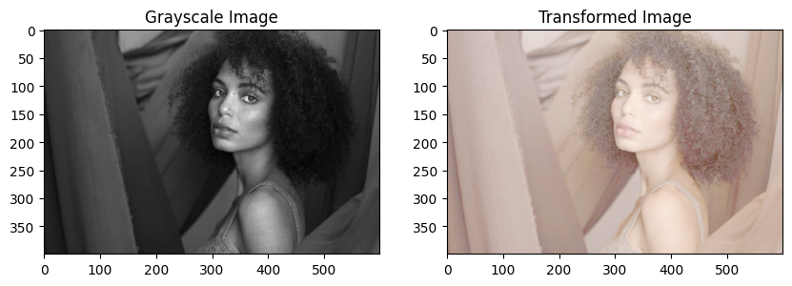

**b. Power transformation**

# Power transformation function

def power_transform(image, gamma=1.0):

    # Apply power transformation

    transformed_image = np.uint8(255 * (image / 255) ** gamma)

    return transformed_image

pow_trans_img = power_transform(gray_img,0.2)

show_2_images(gray_img,pow_trans_img,'Grayscale Image','Transformed Image(Gamma = 0.2)')

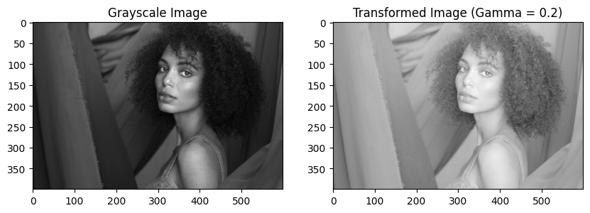

pow_trans_img = power_transform(gray_img,1.5)

show_2_images(gray_img,pow_trans_img,'Grayscale Image','Transformed Image (Gamma = 1.5)')

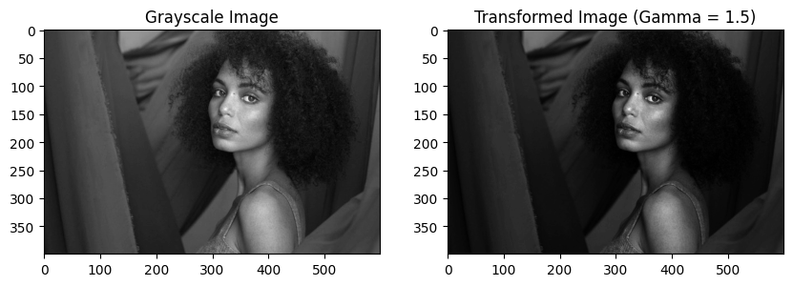

**c. Contrast Stretching**

# Contrast Stretching function

def piecewise_linear_transform(pix, r1, s1, r2, s2):

    if (0 <= pix and pix <= r1):

        return (s1 / r1)*pix

    elif (r1 < pix and pix <= r2):

        return ((s2 - s1)/(r2 - r1)) * (pix - r1) + s1

    else:

        return ((255 - s2)/(255 - r2)) * (pix - r2) + s2

# Vectorize the function to apply it to each value in the Numpy array.

contrast_stretching = np.vectorize(piecewise_linear_transform)

contrast_stretched_img = contrast_stretching(gray_img, 50,30,170,255)

show_2_images(gray_img,contrast_stretched_img,'Grayscale Image', 'Transformed Image')

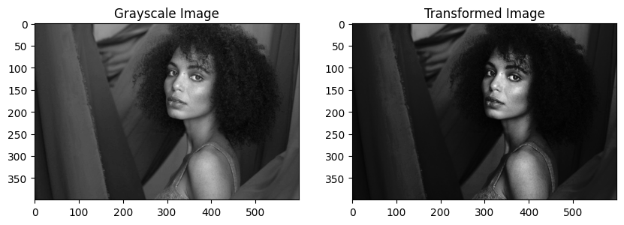

**d. Gray level slicing**

# Gray level slicing function

def gray_level_slicing(image, min_intensity, max_intensity):

    row, column= image.shape

    #  Create an zeros array to store the sliced image

    sliced_image = np.zeros((row,column),dtype = 'uint8')

    #  Specify the min and max range

    min_range = min_intensity

    max_range = max_intensity

    # Loop over the input image and if pixel value lies in desired range set it to 255

    # otherwise set it to desired value

    for i in range(row):

        for j in range(column):

            if gray_img[i,j]>min_range and gray_img[i,j]<max_range:

                sliced_image[i,j] = 255

            else:

                sliced_image[i,j] = gray_img[i-1,j-1]

    return sliced_image

gray_sliced_img = gray_level_slicing(gray_img, 90, 220)

show_2_images(gray_img,gray_sliced_img,'Grayscale Image', 'Transformed Image')

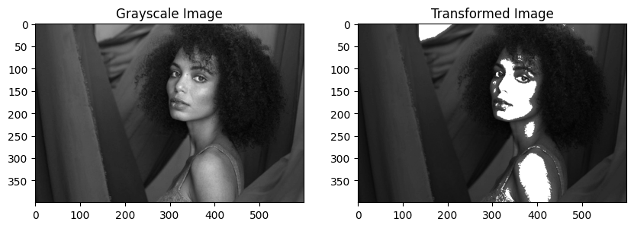

**e. Bit plane slicing**

def bit_plane_slicing(image):

    # Initialize list to store bit planes

    bit_planes = []

    # Iterate over each bit plane from 0 to 7

    for bit in range(8):

        # Apply bit plane slicing

        bit_plane = (image >> bit) & 1

        # Convert the bit plane to 8-bit unsigned integer

        bit_plane = np.uint8(bit_plane * 255)

        # Append the bit plane to the list

        bit_planes.append(bit_plane)

    return bit_planes

bit_sliced_imgs = bit_plane_slicing(gray_img)

fig, ax = plt.subplots(3, 3, figsize=(15, 11))

ax[0, 0].imshow(gray_img, cmap='gray')

ax[0, 0].set_title('Original Image')

ax[0, 1].imshow(bit_sliced_imgs[0], cmap='gray')

ax[0, 1].set_title('Bit Plane 1')

ax[0, 2].imshow(bit_sliced_imgs[1], cmap='gray')

ax[0, 2].set_title('Bit Plane 2')

ax[1, 0].imshow(bit_sliced_imgs[2], cmap='gray')

ax[1, 0].set_title('Bit Plane 3')

ax[1, 1].imshow(bit_sliced_imgs[3], cmap='gray')

ax[1, 1].set_title('Bit Plane 4')

ax[1, 2].imshow(bit_sliced_imgs[4], cmap='gray')

ax[1, 2].set_title('Bit Plane 5')

ax[2, 0].imshow(bit_sliced_imgs[5], cmap='gray')

ax[2, 0].set_title('Bit Plane 6')

ax[2, 1].imshow(bit_sliced_imgs[6], cmap='gray')

ax[2, 1].set_title('Bit Plane 7')

ax[2, 2].imshow(bit_sliced_imgs[7], cmap='gray')

ax[2, 2].set_title('Bit Plane 8')

plt.show()

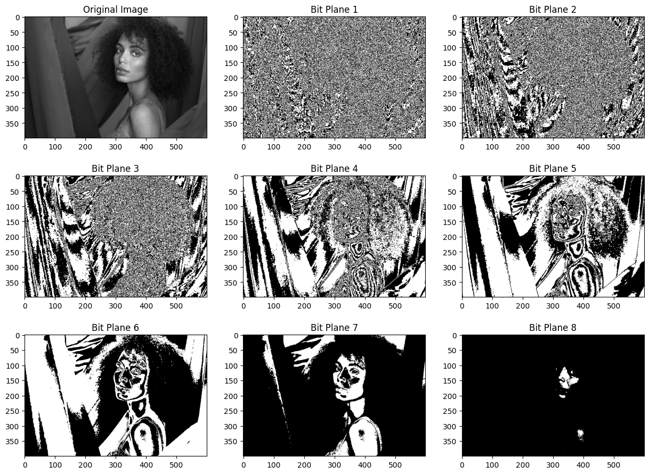

**ii). Consider the graph for a typical transformation function used for Contrast Stretching in the given figure and determine the behavior of the function with respect to given changes.**

**a. When r1 =s1 and r2=s2**

r1 = 40

s1 = 40

r2 = 120

s2 = 120

contrast_stretched_img = contrast_stretching(gray_img, r1, s1, r2, s2)

show_2_images(gray_img,contrast_stretched_img,'Grayscale Image', 'Transformed Image')

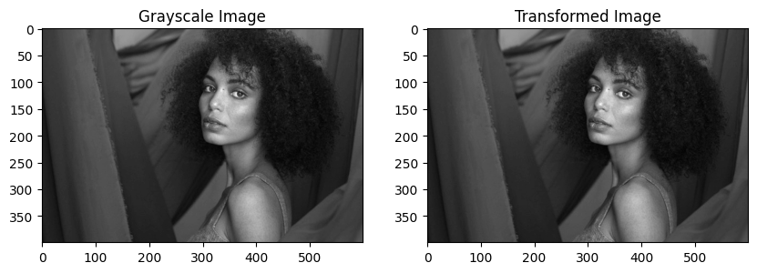

When r1=s1 and r2=s2, the points (r1, s1) and (r2, s2) lie on the line s = r, which is the identity line. This means that the output value s is equal to the input value r for all r, and thus the transformation function does not change the image contrast.

**b. When r1=r2, s1=0 and s2=L-1**

r1 = 40

s1 = 0

r2 = 40

s2 = 255

contrast_stretched_img = contrast_stretching(gray_img, r1, s1, r2, s2)

show_2_images(gray_img,contrast_stretched_img,'Grayscale Image', 'Transformed Image')

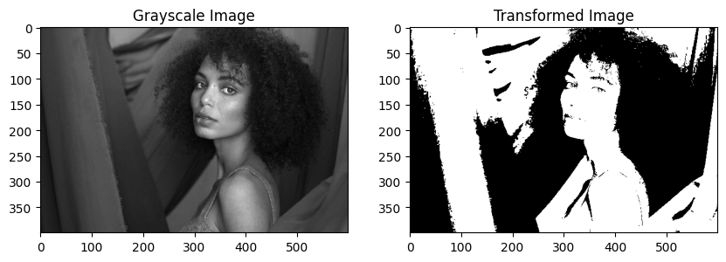

When r1=r2, the transformation function becomes a binary function. For all values of r less than r1, the output s is 0, and for all values of r greater than r1, the output s is L-1. This creates a high-contrast image where all pixel values below a certain threshold are set to 0 (black) and all pixel values above the threshold are set to L-1 (white).

**4. Masking**

**Lab Task 04 : Write a program to read any image, resize it to 256x256. Apply the masks shown in following figures so that only the middle part of the image is visible.**

def apply_mask(image, margin, output_size=256):

    # Resize the image to the specified output size

    image_resized = cv2.resize(image, (output_size, output_size))

    # Create a mask to keep only the middle part of the image visible

    mask = np.zeros_like(image_resized)

    center = output_size // 2

    mask[margin: 255 - margin, margin: 255 - margin] = 255

    # Apply the mask to the resized image

    masked_image = cv2.bitwise_and(image_resized, mask)

    return masked_image

img = plt.imread('image.jpg')

masked_image = apply_mask(img, 30, 256)

show_2_images(img,masked_image,'Original Image', 'Masked Image')

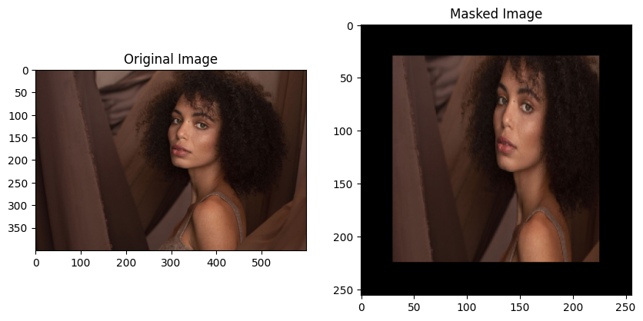

def apply_circular_mask(image, margin, output_size=256):

    # Resize the image to the specified output size

    image_resized = cv2.resize(image, (output_size, output_size))

    # Create a circular mask to keep only the middle part of the image visible

    mask = np.zeros_like(image_resized)

    center = output_size // 2

    radius = output_size // 2

    cv2.circle(mask, (center, center), radius - margin, (255, 255, 255), -1, cv2.LINE_AA)

    # Apply the mask to the resized image

    masked_image = cv2.bitwise_and(image_resized, mask)

    return masked_image

masked_image = apply_circular_mask(img, 10, 256)

show_2_images(img,masked_image,'Original Image', 'Masked Image')

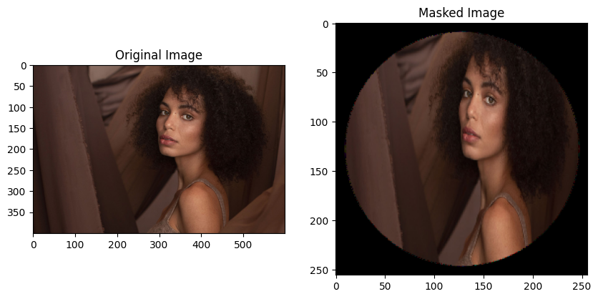

**5. Brightness**

**Lab Task 05 : Write your own Python OpenCV function addbrightness() and use it to increase brightness of a given image.(Hint: Use Image arithmetic operations)**

def add_brightness(image, brightness):

    # Add brightness to the image

    brightened_image = cv2.add(image, brightness)

    return brightened_image

bright_img = add_brightness(img, -50)

show_2_images(img,bright_img,'Original Image', 'Low Brightness')

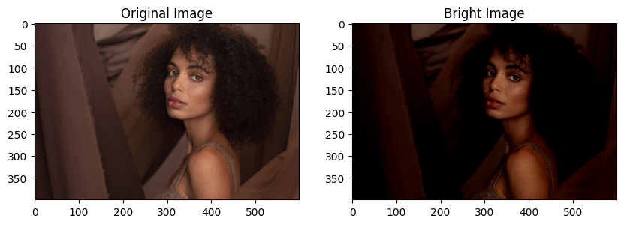

bright_img = add_brightness(img, 80)

show_2_images(img,bright_img,'Original Image', 'High Brightness')

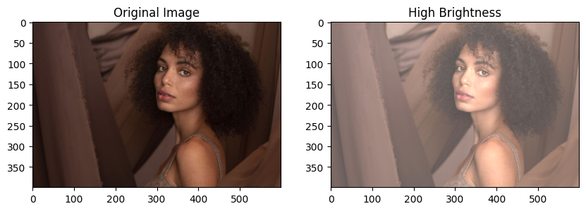

**6. Histogram Processing**

**a. Histogram Calculation in OpenCV**

**Use inbuilt OpenCV cv2.calcHist() function to display the histogram of a given image.**

from io import BytesIO

def display_cv2_histogram(image):

    # find frequency of pixels in range 0-255

    hist = cv2.calcHist([image],[0],None,[256],[0,256])

    plt.hist(image.ravel(),256,[0,256])

    plt.title('Histogram (OpenCV)')

    plt.xlabel('Pixel Value')

    plt.ylabel('Frequency')

    plt.show()

display_cv2_histogram(gray_img)

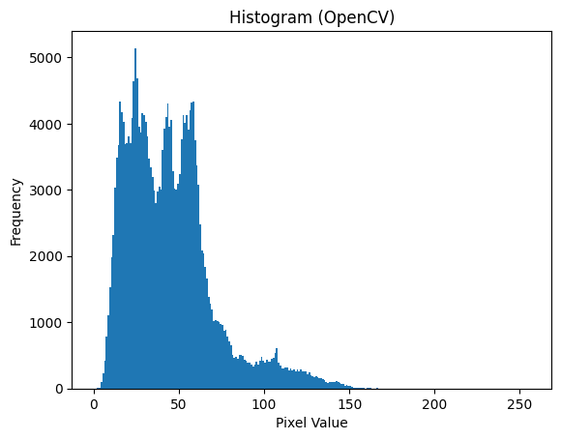

**b. Histogram Calculation in Numpy**

**Use inbuilt numpy np.histogram() function to display the histogram of a given image.**

def display_numpy_histogram(image):

    # Calculate histogram

    hist,bins = np.histogram(image,256,[0,256])

    # Plot histogram

    plt.hist(image.ravel(),256,[0,256])

    plt.title('Histogram (Numpy)')

    plt.xlabel('Pixel Value')

    plt.ylabel('Frequency')

    plt.show()

display_numpy_histogram(gray_img)

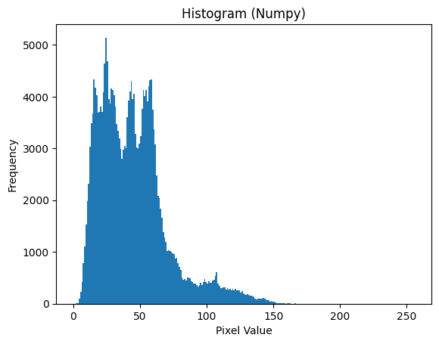

**c. Then write your own histogram functions for the following scenarios**

**i. Show a histogram plot for a grayscale image.**

**ii. Show three histograms for a given RGB image.**

def grayscale_histogram(image):

    # Calculate histogram

    # hist, bins = np.histogram(image.flatten(), 256, [0, 256])

    # Plot histogram

    plt.hist(image.ravel(),256,[0,256])

    plt.title('Grayscale Histogram')

    plt.xlabel('Pixel Value')

    plt.ylabel('Frequency')

    plt.show()

grayscale_histogram(gray_img)

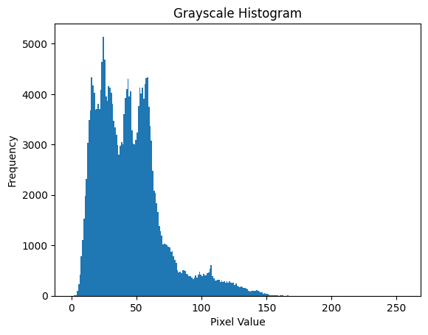

def rgb_histogram(image):

    # Separate color channels

    red_channel = image[:,:,0]

    green_channel = image[:,:,1]

    blue_channel = image[:,:,2]

    # Plot histograms

    plt.figure(figsize=(15, 5))

    plt.subplot(1, 3, 1)

    # plt.plot(hist_red, color='red')

    plt.hist(red_channel.ravel(),256,[0,256], color='red')

    plt.title('Red Channel Histogram')

    plt.xlabel('Pixel Value')

    plt.ylabel('Frequency')

    plt.subplot(1, 3, 2)

    plt.hist(green_channel.ravel(),256,[0,256], color='green')

    plt.title('Green Channel Histogram')

    plt.xlabel('Pixel Value')

    plt.ylabel('Frequency')

    plt.subplot(1, 3, 3)

    plt.hist(blue_channel.ravel(),256,[0,256], color='blue')

    plt.title('Blue Channel Histogram')

    plt.xlabel('Pixel Value')

    plt.ylabel('Frequency')

    plt.tight_layout()

    plt.show()

rgb_histogram(img)

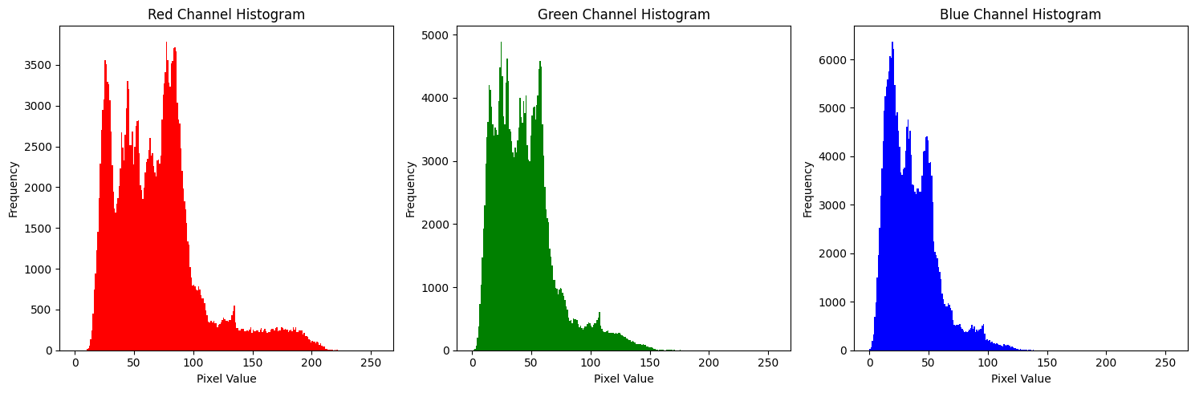

**d. Consider the four images given in the resources folder. Plot the histogram for each image. Perform Histogram Equalization on each image and plot the histograms of the resultant images. Comment on the results you have obtained.**

def plot_histogram(image, title, main_title):

     # Calculate histogram

    hist = cv2.calcHist([image], [0], None, [256], [0, 256])

    # Plot histogram

    plt.figure(figsize=(10, 5))

    plt.subplot(1, 2, 1)

    plt.suptitle(main_title)

    plt.imshow(image, cmap='gray')

    plt.title("Original Image")

    plt.axis('off')

    plt.subplot(1, 2, 2)

    plt.hist(image.ravel(),256,[0,256], color='black')

    plt.title(title)

    plt.xlabel('Pixel Value')

    plt.ylabel('Frequency')

    plt.xlim([0, 256])

    plt.tight_layout()

    plt.show()

# Loading the images

ref1 = plt.imread('bright.jpg')

ref2 = plt.imread('dark.jpg')

ref3 = plt.imread('high_contrast.jpg')

ref4 = plt.imread('low_contrast.jpg')

# Plotting image and their histogram before Histogram Equalization

plot_histogram(ref1, 'Histogram (Bright Image)', 'Before Histogram Equalization')

plot_histogram(ref2, 'Histogram (Dark Image)', 'Before Histogram Equalization')

plot_histogram(ref3, 'Histogram (High Contrast Image)', 'Before Histogram Equalization')

plot_histogram(ref4, 'Histogram (Low Contrast Image)', 'Before Histogram Equalization')

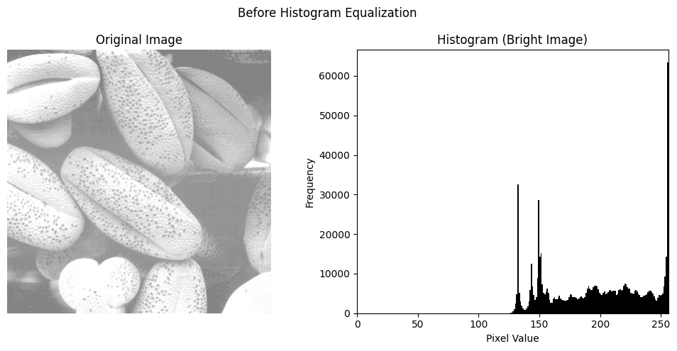

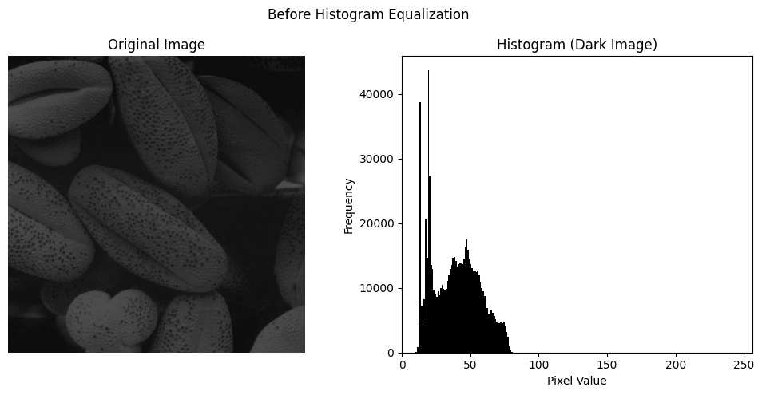

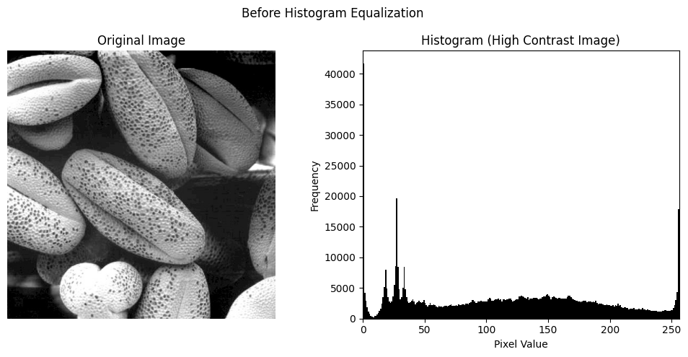

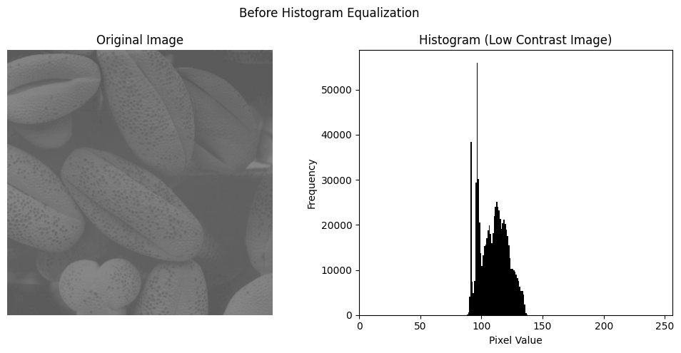

def histogram_equalization(image, title, main_title):

    # Convert image to grayscale

    gray = cv2.cvtColor(image, cv2.COLOR_BGR2GRAY)

    # Perform histogram equalization

    equalized = cv2.equalizeHist(gray)

    # Plot histogram

    plt.figure(figsize=(10, 5))

    plt.subplot(1, 2, 1)

    plt.suptitle(main_title)

    plt.imshow(equalized, cmap='gray')

    plt.title("Resultant Image")

    plt.axis('off')

    plt.subplot(1, 2, 2)

    plt.hist(equalized.ravel(),256,[0,256], color='black')

    plt.title(title)

    plt.xlabel('Pixel Value')

    plt.ylabel('Frequency')

    plt.xlim([0, 256])

    plt.tight_layout()

    plt.show()

# Plotting image and their histogram after Histogram Equalization

histogram_equalization(ref1,'Histogram (Bright Image)','After Histogram Equalization')

histogram_equalization(ref2,'Histogram (Dark Image)','After Histogram Equalization')

histogram_equalization(ref3'Histogram(High Contrast Image)','After Histogram Equalization')

histogram_equalization(ref4,'Histogram(Low Contrast Image)','After Histogram Equalization')

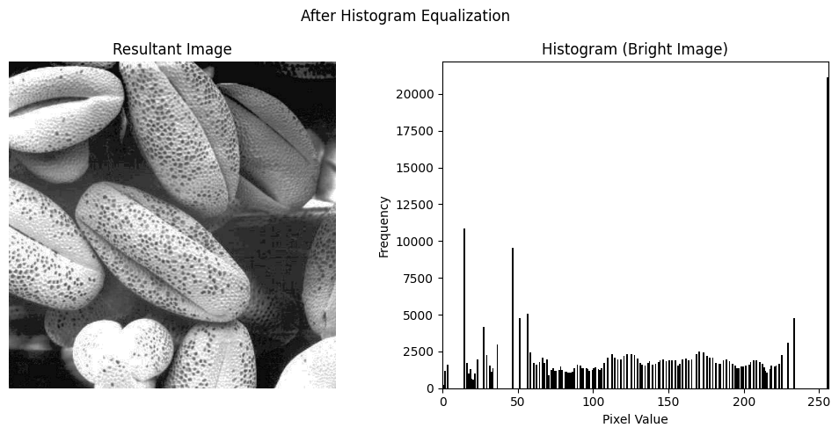

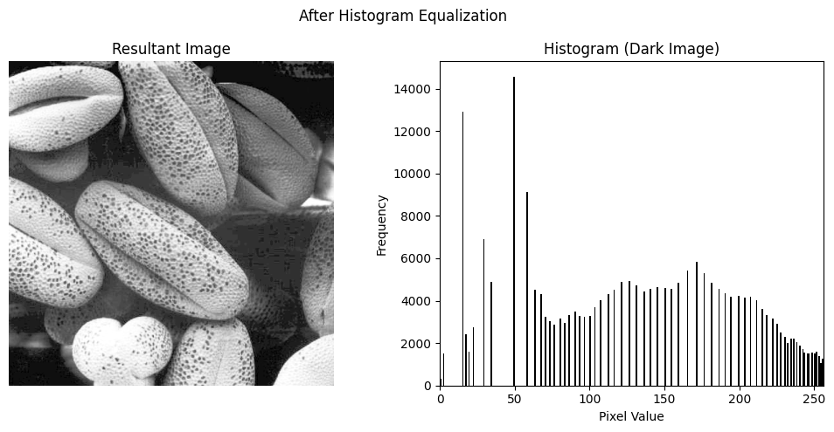

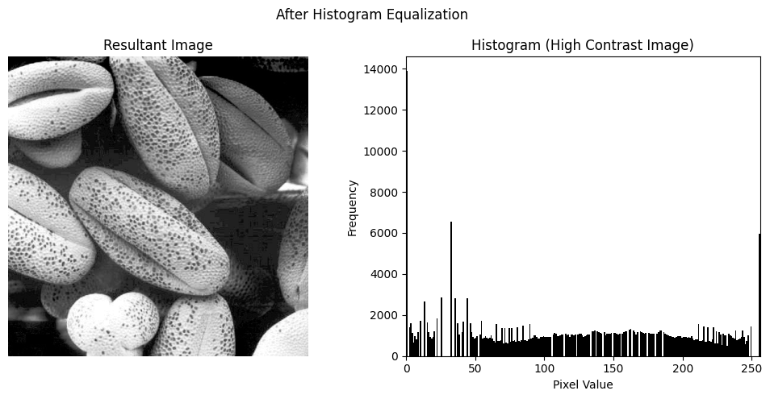

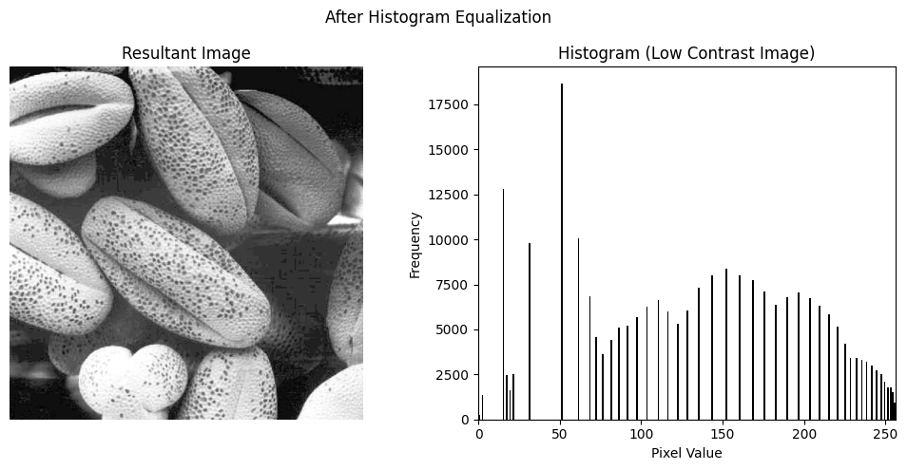

Histogram equalization enhances the contrast of images by spreading out the intensity values. The equalized images tend to have better contrast and detail compared to the original images, as seen in the histograms. However, sometimes histogram equalization can lead to unnatural-looking images, especially when there are already high contrasts in the original images. It's essential to evaluate the results based on the specific characteristics of each image.